Lab 7b Report: Data Science Insights (Titanic Dataset)
1. Data Preparation and Cleaning
The analysis began by importing the titanic.csv dataset.
- Initial Observations: The raw dataset contained 891 observations.
- Missing Values: A total of 177 missing values were identified, all located within the Age column.
- Cleaning Process: To ensure accuracy in calculations, the na.omit() function was used to remove these rows. The final cleaned dataset used for this report consists of 714 passengers.

2. Key Findings and Insights
A. Survival by Port of Embarkation
Using the prop.table() and table() functions, I analyzed the relationship between the boarding location and survival rates.
- Cherbourg (C): Had the highest survival rate at 60.77%.
- Southampton (S): Had a survival rate of 36.28%.
- Queenstown (Q): Had the lowest survival rate at 28.57%.
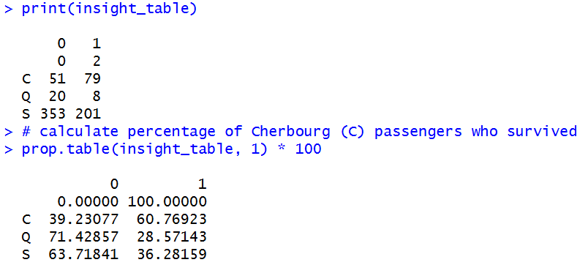
Observation: Passengers boarding at Cherbourg were nearly twice as likely to survive as those boarding at Queenstown. This often correlates with the fact that many First-Class passengers boarded at Cherbourg.

B. High-Value Passengers (Fare Analysis)
By applying the filter() and arrange() functions from the dplyr library:
- I identified that the highest fare paid was £512.33.
- When sorting the data by Fare in descending order, it becomes clear that survival was highly correlated with the ticket price. Most passengers in the "Top 10" highest fares survived the disaster.

C. Gender-Based Survival
By filtering specifically for females (Sex == 'female'), the data confirms the "women and children first" protocol.
- The females_survived dataframe shows a vast majority of the female passengers in First and Second class were successfully rescued.
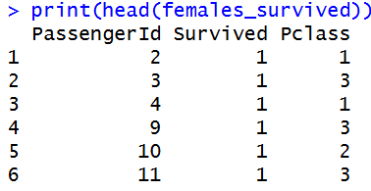
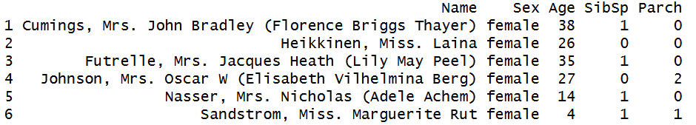
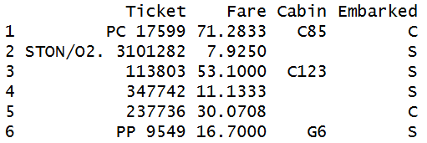

3. Conclusion
The analysis of the Titanic dataset demonstrates that survival was not random. It was heavily influenced by socio-economic status (represented by Fare and Pclass) and geographic points of origin (Embarked).
Files produced for this lab:
- titanic_cleaned_7a.csv: The dataset with NAs removed.
- Titanic_Final_Report.csv: The cleaned data sorted by the highest ticket fares.

